***Pilot’s Guide***

Welcome to Golden Age Aviation, where we relive the elegance, adventure and spirit of aviation’s finest years. Step back into the golden era of flight and experience the skies as they were meant to be.  
  
Here is a guide on how to join our community: -

1. Click on Join Us, it will redirect you to Vamsys which will allow you to join our Virtual Airlines.

1. Register yourself with your Email ID. If you already have a Vamsys account, you can click Login at bottom
2. After joining this is the page you will be greeted with this page.

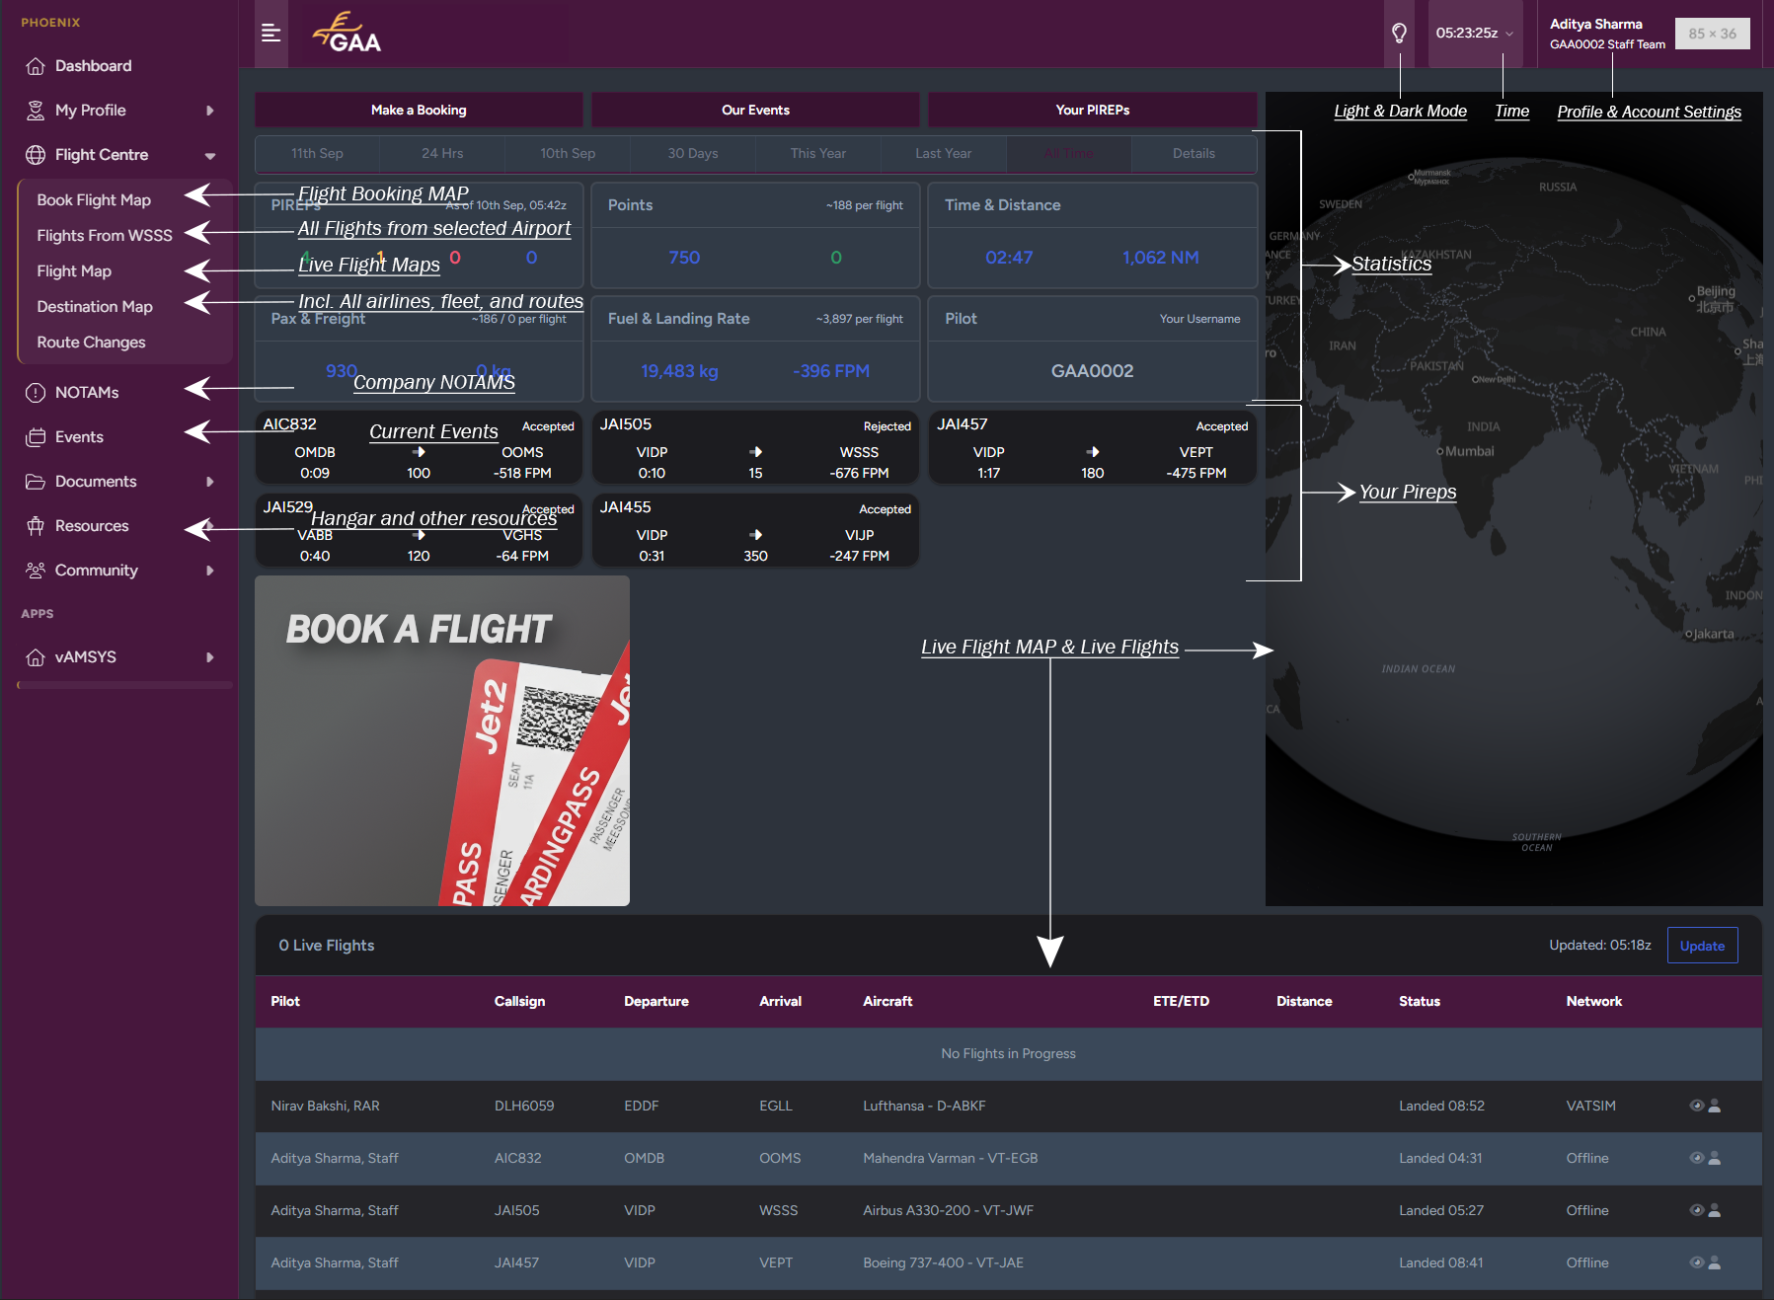

1. In the above image, you will find an overview of Vamsys.
2. Inside the Hangar you will find all the liveries for most of the addons and simulators. (TBA)
3. It’s highly recommended to join our discord server to get updates about changes and new events.
4. To join our discord server, click on the logo on top right upper corner of the screen or [here](https://discord.gg/bHAmUDffKQ).
5. After joining our discord server, you should automatically get verified.
6. If not verified automatically you can click on **REQUEST ACCESS** in [#rules](https://discord.com/channels/1410169335712059394/1410171967989878905).
7. After getting verified through Vamsys, our nickname should change from “username” to “Vamsys Account Name – Vamsys ID”, as well as you should have received a role of Ramp-Rookie .

If it doesn’t change automatically, drop an email on [support@goldenageaviation.org](mailto:support@goldenageaviation.org). (Note: - You can still fly on Vamsys even if you don’t have your discord linked)

1. After receiving your updated nickname and Vamsys is linked to discord, you will get access to [#get-verified](https://discord.com/channels/1410169335712059394/1412703654028247120) channel, this confirms you have verified correctly.
2. Now, go to that channel and react with ✅ to get access to all the discord channels.

1. To get notifications regarding any Alerts, NOTAM, and activity. Go to [#self-roles](https://discord.com/channels/1410169335712059394/1410450848357548062) and react with the embed messages to get push notifications regarding any updates.

